Ingenious Makers P11 – ESPHome Panasonic Climate Interface
by michel · Published March 8, 2025 · Updated April 5, 2025
Table of Contents
- Getting the Panasonic Climate control off the cloud
- How does it work?
- Design parameters
- PCB design
  - PCB
- Bill of materials
- Putting it together
- Wiring
- Finished module
- Installation

    - DNSK-P11 replacement:
    - CZ-TACG1 replacement:
  - Software
    - esphome config
Getting the Panasonic Climate control off the cloud
Back in August 2021, we published an article about an ESPHome component for an ESP32 or ESP8266-based air conditioning/climate WiFi interface—a great way to get your Panasonic Climate Control off the Panasonic Comfort Cloud and into Home Assistant locally. The only thing missing was a proper hardware solution, so we developed one and published our initial design in our blog-article here.
Our SMD design perfectly replaced the original Panasonic Climate interface and even fitted the original enclosure. The only disadvantage was that an SMD design is extremely hard to build yourself. We received a lot of requests to sell a pre-built interface, which were soon sent all over the planet, costing us loads of time. That is not what we are about. We want to design hardware that you can easily build yourself, so we published our DIY version of the Panasonic Climate Interface.
The original design was based on the ESP32-C3 Mini module (Wemos D1 Mini sized), which is no longer broadly available. Our new design is based on the widely available ESP32-C3 Super Mini, which is even more compact and works just the same.
How does it work?
Panasonic Climate units are typically connected to Panasonic’s Comfort Cloud using either a DNSK-P11 or a CZ-TACG1 WiFi interface.
CZ-TACG1 | DNSK-P11
If you have one of these interfaces installed, you may find yourself dealing with the frustrations of using the Panasonic Cloud service. This often involves repeatedly logging in to your app and being unable to control your Climate unit due to cloud service outages. If you do not have one of these interfaces installed, you are likely limited to controlling your Climate unit with only the standard remote control that comes with it.
The Solution
Fortunately, there is a solution to these problems. A custom ESPHome component allows you to connect Home Assistant to your Panasonic Climate locally. With this setup, remote controlling your Climate unit becomes instant and independent of the cloud. Now, the only thing needed is some hardware to act as the bridge between Home Assistant and the Panasonic Climate.
Design parameters
Our requirements:
- Must be able to connect to both the CN-CNT and the DNSK-P11 connector
Must work as a DNSK-P11 or CZ-TACG1 replacement
- Preferably have the same size as the original interface
- Must support an external DS18B20 temperature sensor
- Must have a USB-C terminal for esphome installation
- Enclosure must be readily available or 3D printable
So we designed a PCB for a ESP32-C3 Super Mini module.
PCB design
We where able to come up with a simple yet effective design using only 9 simple components. Add the ESP32-C3 Super Mini and a connector and you have yourself a working Panasonic Climate Interface for Home Assistant.
PCB
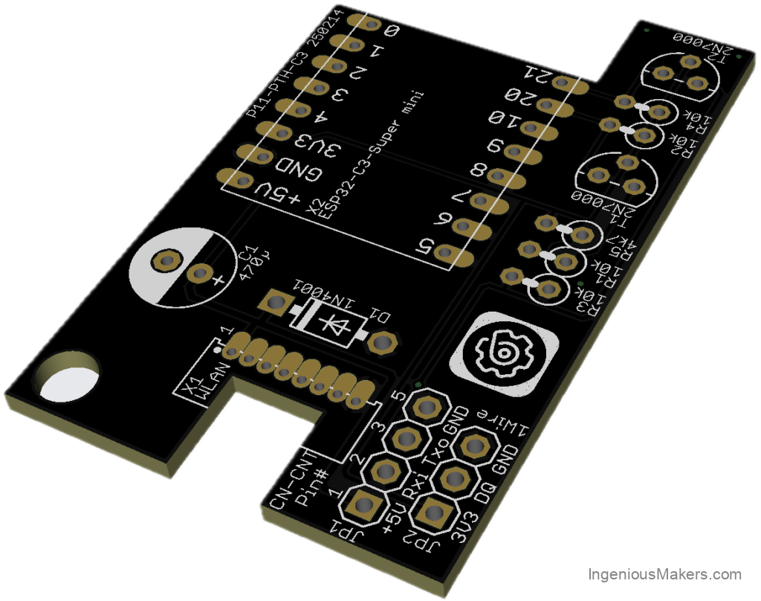
Bill of materials
See below the list with the components you will need to build the Ingenious Makers P11 controller. A number of these items will not be sold in smaller quantities at AliExpress. We will try to use the same components as much as possible in other projects.
We would really appreciate it if you will use the links below to buy the components, since it will give a little bit of commission to us without any additional cost for yourself. These commissions will be used to cover some of the costs involved in the development of the design.
Reference | Quantity | Description | Affiliate
ESP32-C3 Super Mini | 1 | ESP32-C3 Super Mini  (comes with 2 strips of 8-pin headers) | Link
T1, T2 | 2 | 2N7000 TO92 Small Signal MOSFET 200 mAmps, 60 Volts | Link
D1 | 1 | 1N4001 | Link
C1 | 1 | 470µF / 10V or 16V 6mm diameter, 2.54mm pitch | Link
R1, R2, R3, R4 | 4 | Resistor 10KΩ | Link
R5 | 1 | Resistor 4.7KΩ | Link
JP1 | 1 | 5 pin PAP-05V-S connector with wires (cut duponts and solder!)  Only needed for CZ-TACG1 | Link
JP2 | 1 | Optional: Wired DS18B20 temperature sensor | Link
Enclosure | 1 | 3d-Printable Enclosure, specifically for this interface | Link
X1 | 5 | 1.27mm pin header  Only needed for DNSK-P11 | Link
PCB | 1 | PCB ET-P1101 from PCBway | Link
Putting it together
DISCLAIMER: We are frequently receiving questions from commercial hardware stores about our designs. How to build, which component or connector to use etc. We are all about DIY. If you can not build this module yourself using our instructions and some basic knowledge, please do not acquire them from commercial hardware stores, but abandon this project all-together. If you are however building this yourself and you have any further questions, you may post those in the comments and we will do our best to answer those in due time.
Like with all other projects, it is the easiest to start with identifying the components purchased as discussed in our soldering blog post. After sorting the components and cleaning the PCB, start with the lowest components first. For this project, we advise to work in this order:
- DNSK-P11 header* (not required if you are attaching it to the CN-CNT to replace a CZ-TACG1 Wifi module)
- Diode
- MOSFETs
- Resistors
- Electrolytic capacitor
- ESP module headers (Use the hints in the soldering blog post!)
- CZ-TACG1 cable (only If you are attaching it to CN-CNT connector)
* Use a very small soldering tip for the 1.27mm headers and use minimal amount of soldering wire. Make sure it melts and flows out sufficiently.
Once all components are soldered in place, perform a good visual check of all joints, and pay particular attention to possible solder bridges (unwanted solder connections between pins). Do not forget to clean the excess solder flux from the PCB using alcohol!
Wiring
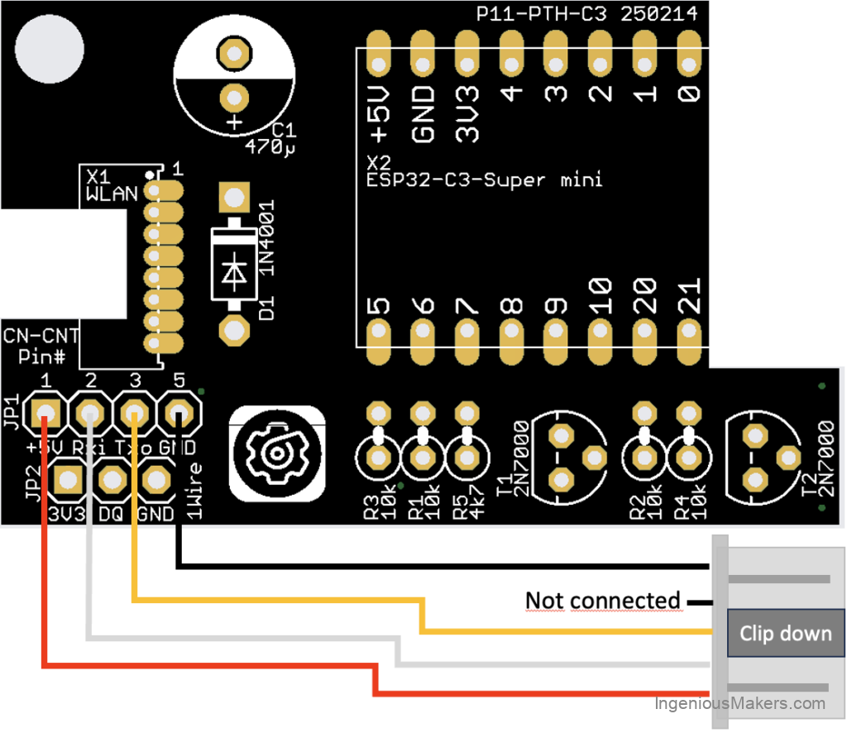
Finished module
Either solder the DNSK-P11 header or the CN-CNT cable. You only need one of both, depending on your climate unit!
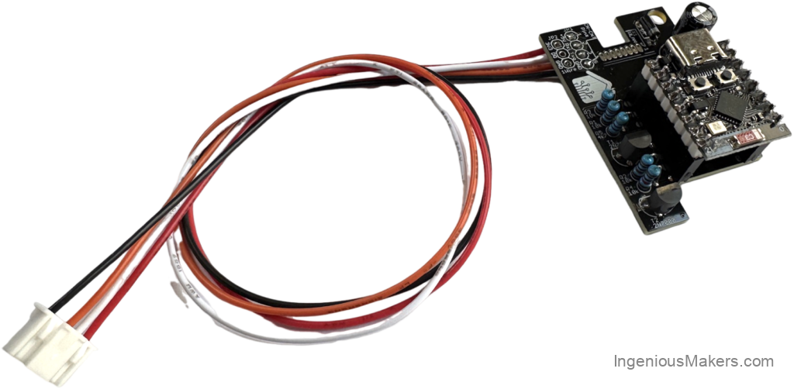
Installation
DNSK-P11 replacement:

Original DNSK-P11 enclosure
Below a video on how to install the original CZ-TACG1 interface. The interface is different, but you’ll find clear instructions on how to open and close the unit. After taking off the enclosure, check your Climate unit for the DNSK-P11 enclosure.
Watch this video on YouTube.
Please subscribe to our YouTube channel and hit the bell to support us!
Take the DNSK-P11 pcb out of the enclosure carefully, remove the black connector from the PCB and install your Ingenious Makers P11 interface. Connect the interface using the original DNSK-P11 cable. The connector-lip needs to go downwards in the notch of the PCB, the flat part of the connector up.
Please be careful as the pins are tiny. If you use your brain in stead of brute force, you’ll be ok.
CZ-TACG1 replacement:
You can either replace the original CZ-TACG1interface, or if you have no Wifi interface installed yet and your Panasonic unit has the 5-pin CN-CNT connector, you are good to install the Ingenious Makers Wifi interface.

CN-CNT connector
Below a video on how to install the original CZ-TACG1 interface. The installation of the P11 interface with the cable (option 5), is pretty straight forward.
Watch this video on YouTube.
Please subscribe to our YouTube channel and hit the bell to support us!
Software
esphome config
Create a new esphome device and use the following configuration example:
substitutions:
devicename: esp32-airco-01
long_devicename: Panasonic Climate Office
pcb_version: "P11-PTH-C3 250214"
esphome:
name: "${devicename}"
name_add_mac_suffix: false
comment: "${long_devicename} ${pcb_version}"
esp32:
board: esp32-c3-devkitm-1
framework:
type: esp-idf
variant: ESP32C3
external_components:
source: github://DomiStyle/esphome-panasonic-ac
components: [panasonic_ac]
wifi:
ssid: !secret esphome_wifi_ssid
password: !secret esphome_wifi_password
ap:
ssid: "${devicename} Hotspot"
password: !secret esphome_ap_password
captive_portal:
web_server:
port: 80
logger:
level: DEBUG
api:
encryption:
key: !secret esphome_api_key
ota:
- platform: esphome
password: !secret ota_password
bluetooth_proxy:
uart:
tx_pin: GPIO21
rx_pin: GPIO20
id: ac_uart
baud_rate: 9600
parity: EVEN
switch:
- platform: restart
name: "$long_devicename Restart"
climate:
- platform: panasonic_ac
id: office
type: cnt
name: "$long_devicename"
vertical_swing_select:
name: "$long_devicename Vertical Swing Mode"
outside_temperature:
name: "$long_devicename Outside Temperature"
current_power_consumption:
id: power_consumption_office
name: "$long_devicename Power Consumption"
unit_of_measurement: W
accuracy_decimals: 0
device_class: power
state_class: measurement
sensor:
- platform: total_daily_energy
name: "$long_devicename Total Daily Energy"
power_id: power_consumption_office
filters:
- multiply: 0.001
unit_of_measurement: kWh
device_class: energy
time:
- platform: homeassistant
id: my_time
End result

